Climbing Training
Aside from climbing, rock climbers often train exercises to help them get better at climbing
If you have lots of energy, try doing some strength exercises that rock climbers do
For your core or abs try the plank
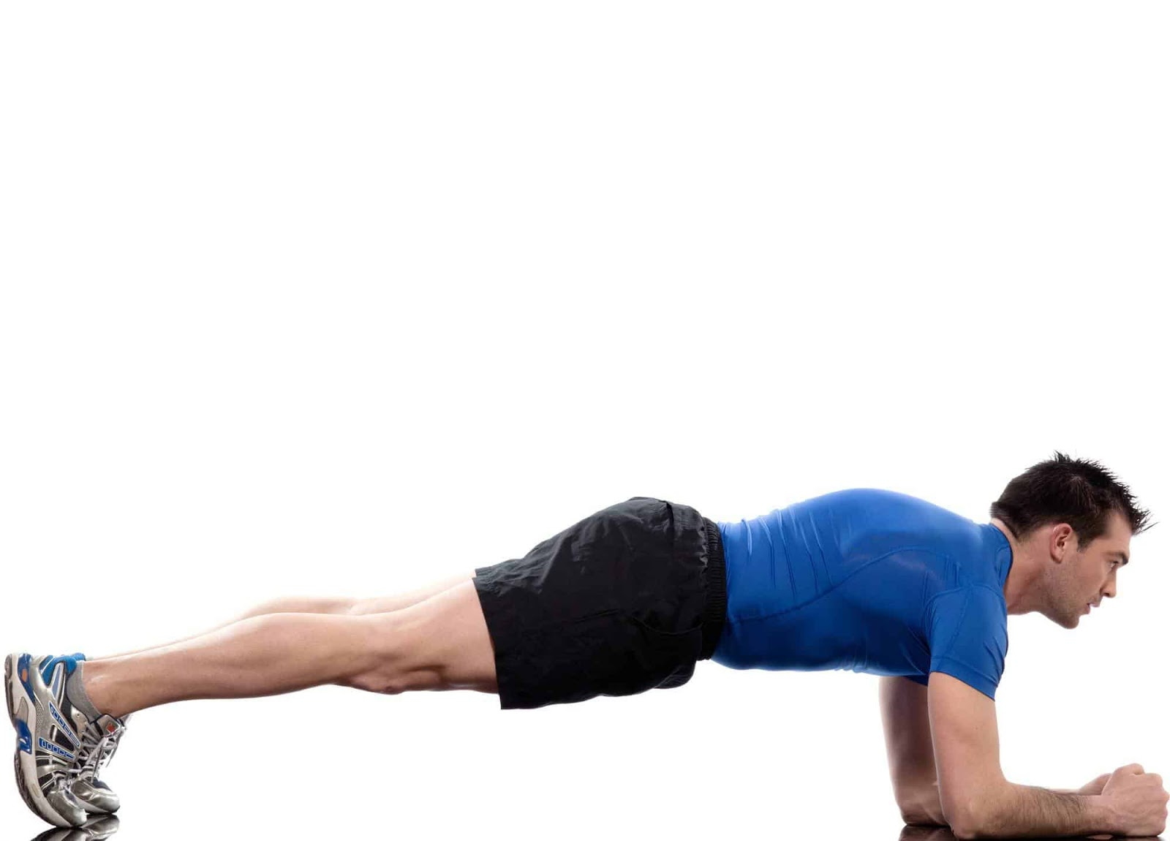
Then do some push-ups
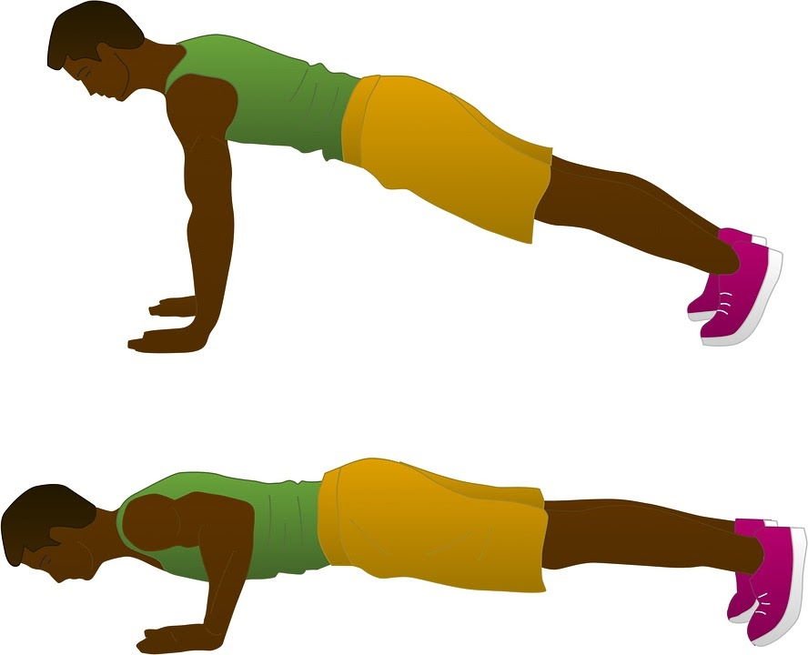
And then find something safe that you can hang off of - like a bar or tree branch
- Make sure you can safely drop down from whatever you choose and make sure that what you’re hanging from will support your weight!
- Then grab on and try to hang on as long as you can!
- If hanging with two arms is too easy - try with only one!
- If you want to get more motivated to hang on just picture that you’re hanging onto the side of a cliff while climbing!

