Homemade Fishing Rod Craft
https://lifestyle.howstuffworks.com/crafts/seasonal/lake-activities2.htm
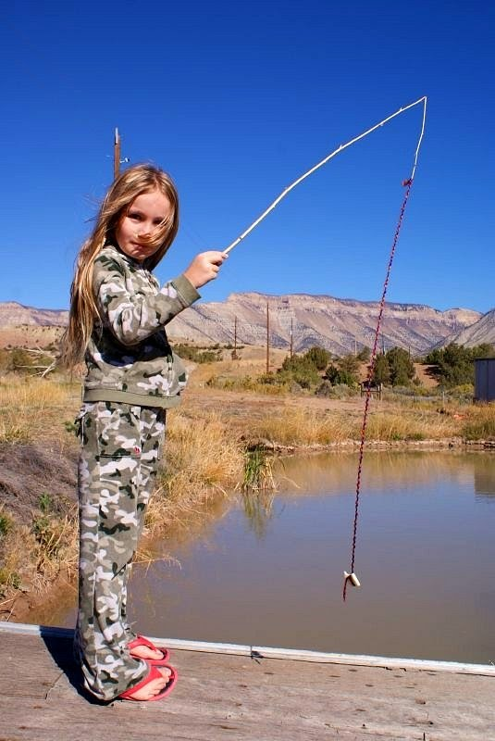
- Make a homemade fishing rod by collecting a stick and some string, rope, or fishing line!
- Once the rope is attached to the homemade fishing rod, you can either attach a real fish hook if your parents allow or you can attach a magnet to the end of the line
- If you decide to attach a magnet, you can invent all sorts of fun games to practice your fishing skills!
- What things are magnetic - can you pick them up? Can you cut fish shapes out of paper and make them magnetic so you can fish for them?
- Can you avoid picking up certain fish to grab specific ones?

