Learn to say your name in semaphore!
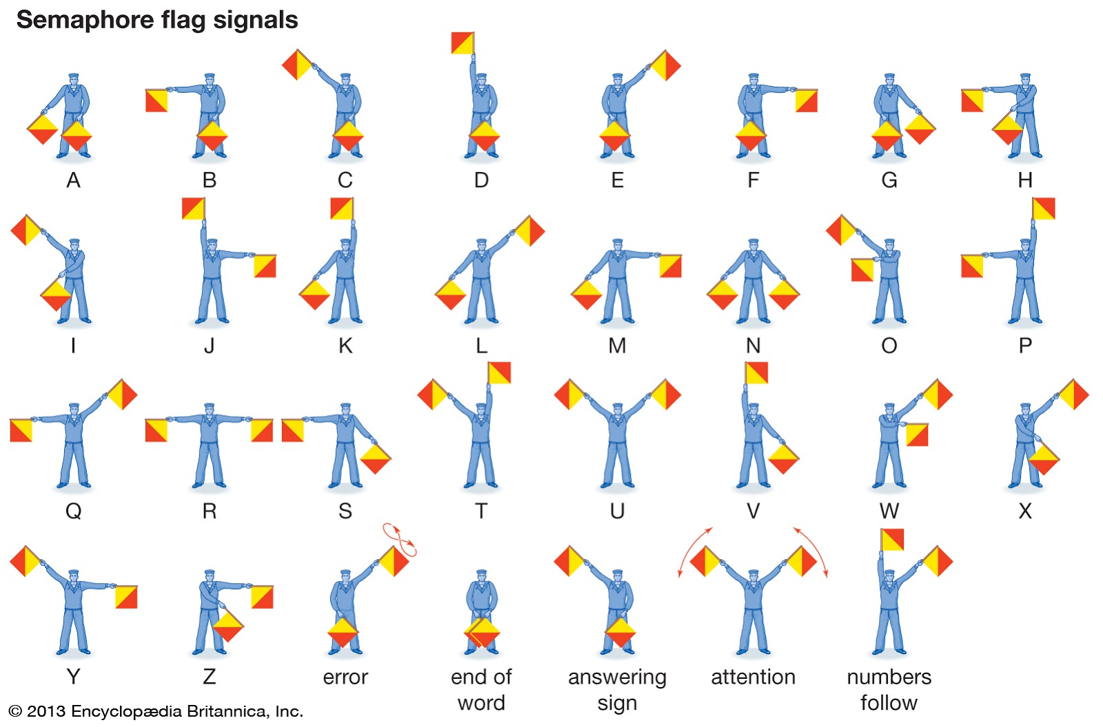
Semaphore is a language used for boats to talk to each other from far away
You “talk” in semaphore by using two flags and putting them in different positions
Grab two colourful things to use as “flags” - they make it easier to see what you’re signing from further away
Take a look at the semaphore alphabet above and try to figure out how to “spell” your name
Practice spelling it out using the semaphore flags - if you’re feeling confident try to also learn other words and maybe even sentences in semaphore
Once you think you’re ready find someone in your household to “talk” to in semaphore - be sure to give them the picture with the letters or else they’ll have no idea!
See how far away you can be from the other person and still communicate - if the other person also wants to learn - practice “hearing” semaphore that they do and see if you can tell what the message is.

