Fishing Hat
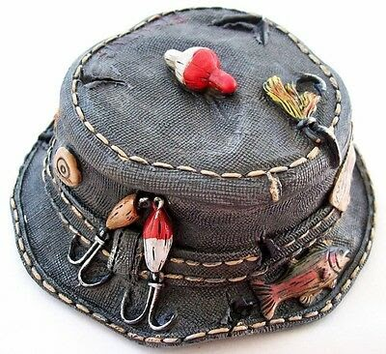
- Fishers often have really cool hats where they store all of their fishing gear
- Even if you don’t have fishing gear, if you can find a hat you can get permission to work on - then you can make your own cool fishing hat!
- You can attach whatever fun fishing related stuff to the outside of the hat with tape or by pinning it on
- If you don’t have any fishing gear to put on, what about creating fish camouflage?
- Imagine a fish is looking out of the water at you, what would you put on a hat to hide from it so you can catch the fish?

