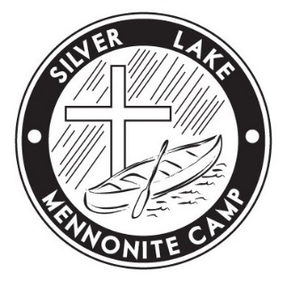
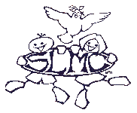
Silver Lake Mennonite Camp

Admin Office: 209 – 50 Kent Avenue, Kitchener ON N2G 3R1

519-422-1401 * fun@slmc.ca

Cabin Rental Agreement

** Silver Lake is designated as nut-free – peanuts or nuts are not allowed onto camp property. **

- You must follow all current Public Health regulations including COVID prevention practices and complete
  - the self-screening questionnaire that you will receive at least one week before arrival
  - the self-screening questionnaire that you will receive upon arrival at Silver Lake Mennonite Camp.

- You are required to provide for basic first aid and advanced medical treatment and/or expenses. Oral medications WILL NOT be dispensed under any circumstances by Silver Lake staff. There is a hospital in Wiarton (15 min.), Southampton (20 min.) and in Owen Sound (30 min.) for emergencies.

- For emergencies only, you can be contacted at (519) 422-1401. Feel free to give out this number.

- Everyone is required to wear a proper lifejacket (PFD) when using the canoes or other waterfront equipment. You are responsible to provide your own lifejackets and supervision at the waterfront. All children, regardless of age must have parent/adult supervision at all times while at the waterfront, swimming or boating. All activities, including waterfront activities (swimming, canoeing, sailing, kayaking) are USE AT YOUR OWN RISK.

- Please leave the camp as clean as you found it. Cabins should be swept and garbage emptied. Garbage should be bagged and placed in the dumpster across from the house and recycling should be taken to the shed beside the dumpster and properly sorted. Silver Lake does not compost for cabin rentals so if you wish to compost please take it home with you. Please take home all the food you brought including leftovers (or throw out). Please turn off heat in your cabin before you leave.

- Consumption or possession of alcoholic beverages or illegal substances is NOT permitted on camp property. All of Silver Lake Mennonite Camp has been designated as a NON-SMOKING area

- To ensure the health and well-being of all, Silver Lake Mennonite Camp (buildings and property) is designated as nut-free. Please carefully check all ingredients and menu items.

- No pets are allowed onsite.

- Normal wear and tear of facilities is included in the rental rate. Any damage or theft that occurs during your stay will be assessed by Silver Lake staff and the resulting bill will be charged to you.

- We are unable to take responsibility for ANY lost items. We strongly recommend that you DO NOT bring electronics, jewelry, cameras or other valuables to camp.

- Both during and following the term of this agreement, you must undertake to indemnify and save harmless Silver Lake Mennonite Camp from and against any and all loss, cost, damages, expense and liability (statutory and common law) arising from the negligence in connection with the injury or death of any person or property or other damage sustained by Silver Lake Mennonite Camp and its directors which may arise out of my/our use of the camp property.

- You must undertake to conduct your activities in a safe and careful manner and assume full responsibility for the conduct of yourself and family, and for the safety of all you must have read, understand and agree to the above conditions for rental of Silver Lake Mennonite facilities.

